**DAILY ONLINE ACTIVITIES SUMMARY**

|  |  |  |  |  |  |  |  |
| --- | --- | --- | --- | --- | --- | --- | --- |
| **Date:** | **21\05\2020** | | | | **Name:** | **AMBIKA - V** | |
| **Sem & Sec** | **4th SEM SECTION 'A'** | | | | **USN:** | **4AL18CS005** | |
| **Online Test Summary** | | | | | | | |
| **Subject** | | **Microcontroller and embeded systems(18CS43)** | | | | | |
| **Max. Marks** | | **30** | | **Score** | | **19** | |
| **Certification Course Summary** | | | | | | | |
| **Course** | **CLOUD FOUNDATION** | | | | | | |
| **Certificate Provider** | | | **GREAT LEARNING ACADEMY** | **Duration** | | | **3.5hrs** |
| **Coding Challenges** | | | | | | | |
| **Problem statement 1:** Write a C program to implement SRTF process scheduling.**Problem statement 2 :** Write a C program to construct a singly linked list by removing duplicate elements in the sorted linked list**Problem statement 3 :** Write a c program to create sll with n elements and reverse the elements using c. | | | | | | | |
| **Status: Executed** | | | | | | | |
| **Uploaded the report in Github** | | | | **yes** | | | |
| **If yes Repository name** | | | | **https://github.com/ambika0202/lockdown-coding-** | | | |
| **Uploaded the report in slack** | | | | **Yes** | | | |

**Online Test Details:**  MES test wasconducted from 10:00 to 10:40 am dated 21 may 2020 .The test include MCQ kind of questions .

The below is the snapshot of the test conducted and analysis of the test was also provieded by the service provider.

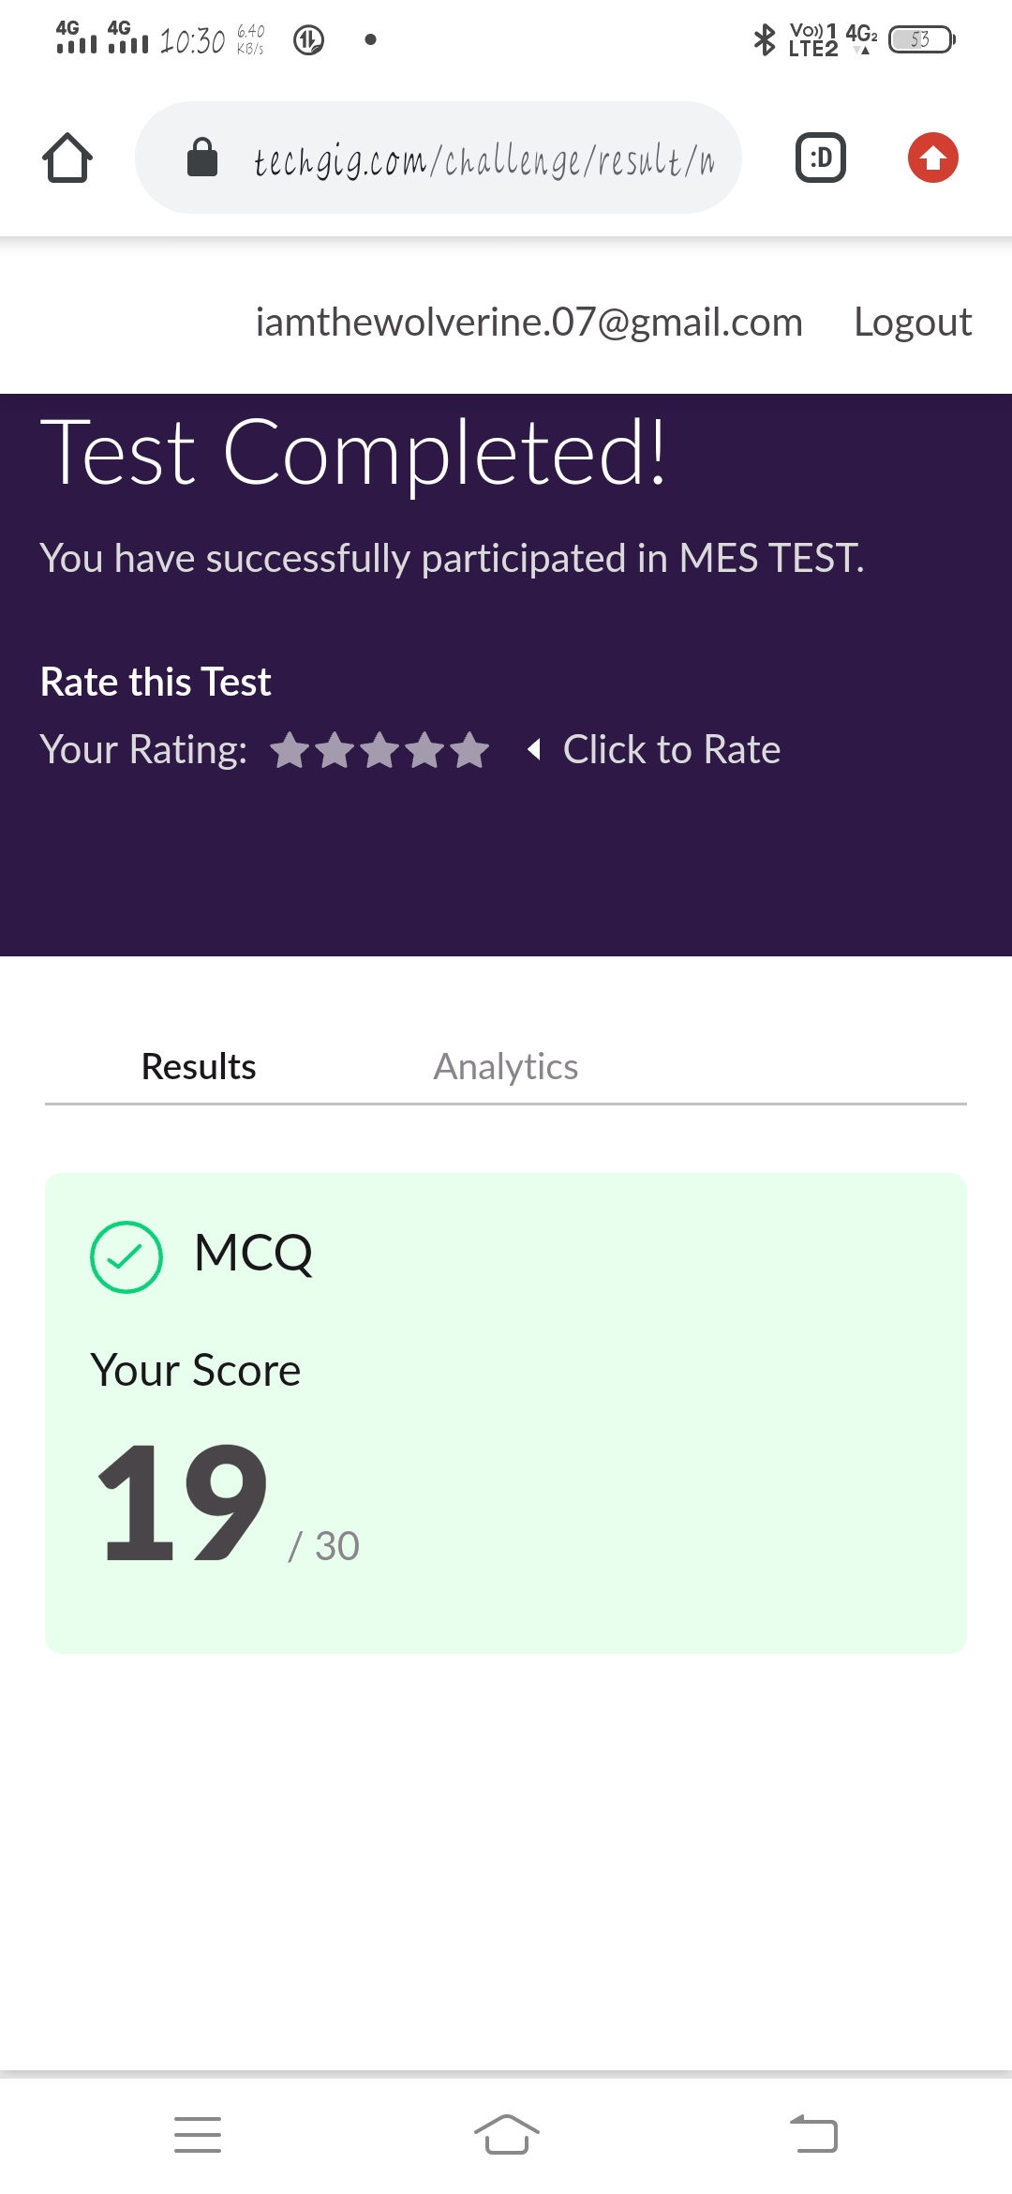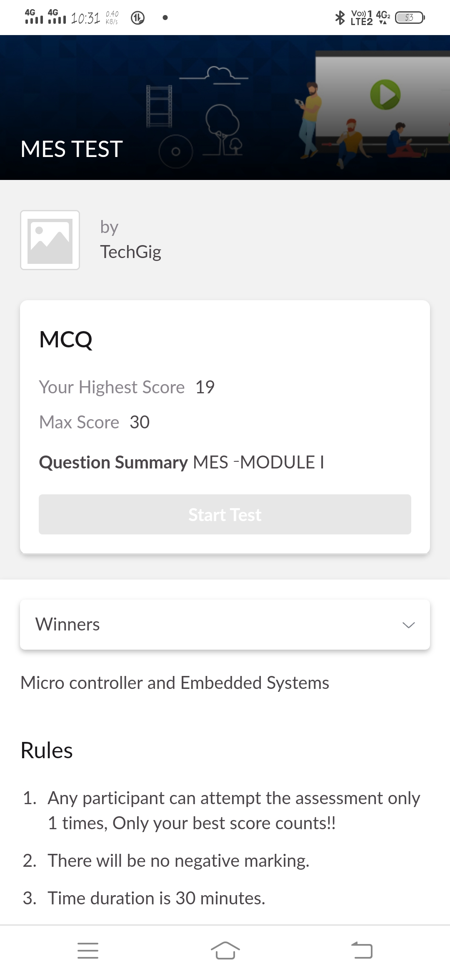

**CERTIFICATIONCOURSEDETAILS**

today i have continued yesterday course of cloud foundation of introduction to virtualization and started a new module Of Containers vs VMs, PaaS & Services Taxonomy.

**1.Introduction to virtualization**

Virtualization is the creation of a simulated version of something else. Computers can create virtual networks, storage, disk drives, operating systems, and other forms of hardware. Physical machines are referred to as "Host" machines while simulated machines are referred to as virtual machines.

Three Kinds of Server Virtualization. There are three ways to create virtual servers: full virtualization, para-virtualization and OS-level virtualization. They all share a few common traits. The physical server is called the host.

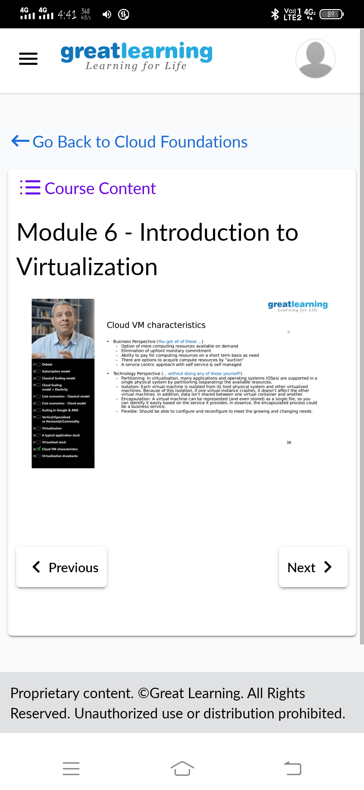

**2.Containers vs VMs, PaaS & Services Taxonomy**

Platform as a service (PaaS) is a cloud computing model in which a third-party provider delivers hardware and software tools -- usually those needed for application development -- to users over the internet. A PaaS provider hosts the hardware and software on its own infrastructure.

The taxonomy model demonstrates the various layers of a virtual server architecture and virtualization domains in a structured way. ... Combining this service with desktop virtualization and user state virtualization allows for a better desktop service offering.

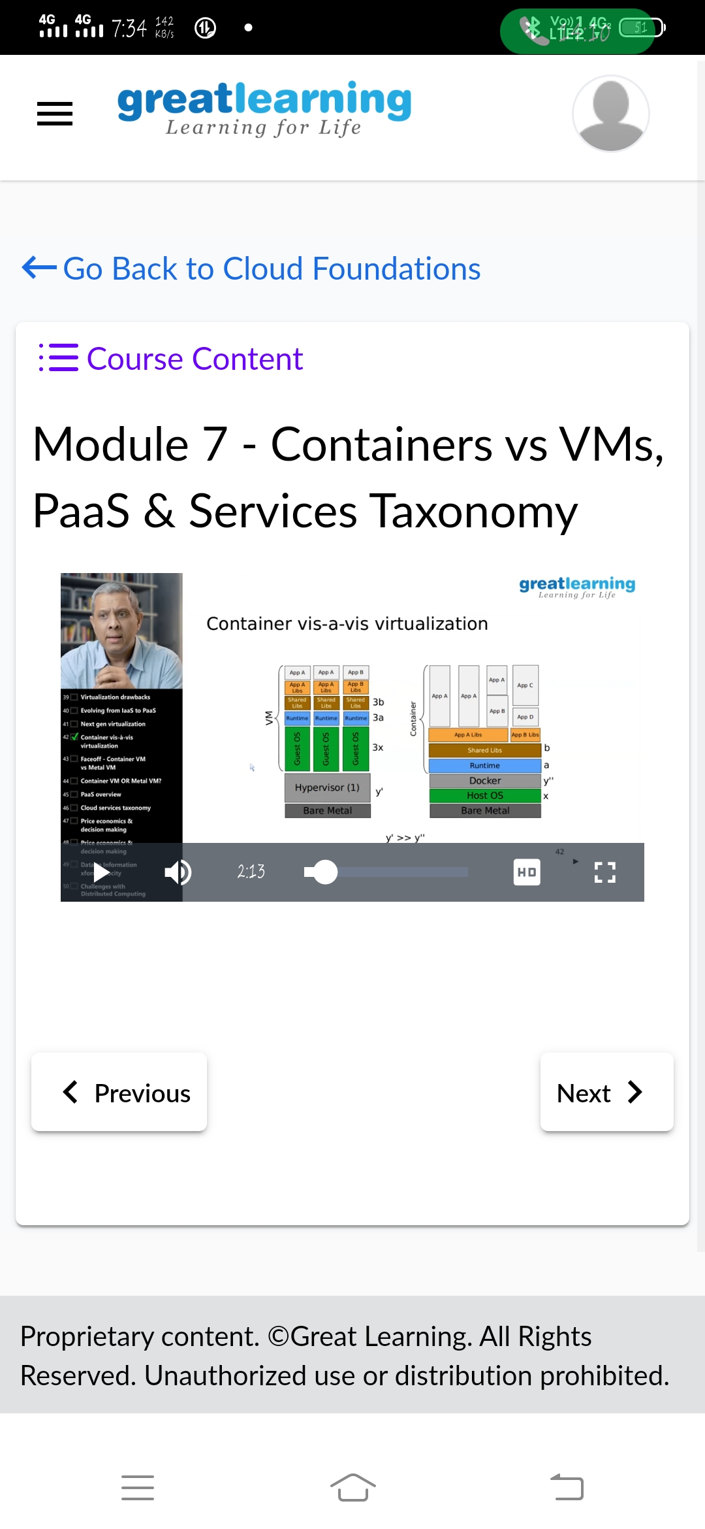

**Coding Challenges Details:**

**Problem statement 1:** Write a C program to implement SRTF process scheduling.

Input: A set of processes with their burst time and arrival time

Output: The processes scheduled based on the arrival time and a smaller burst time.

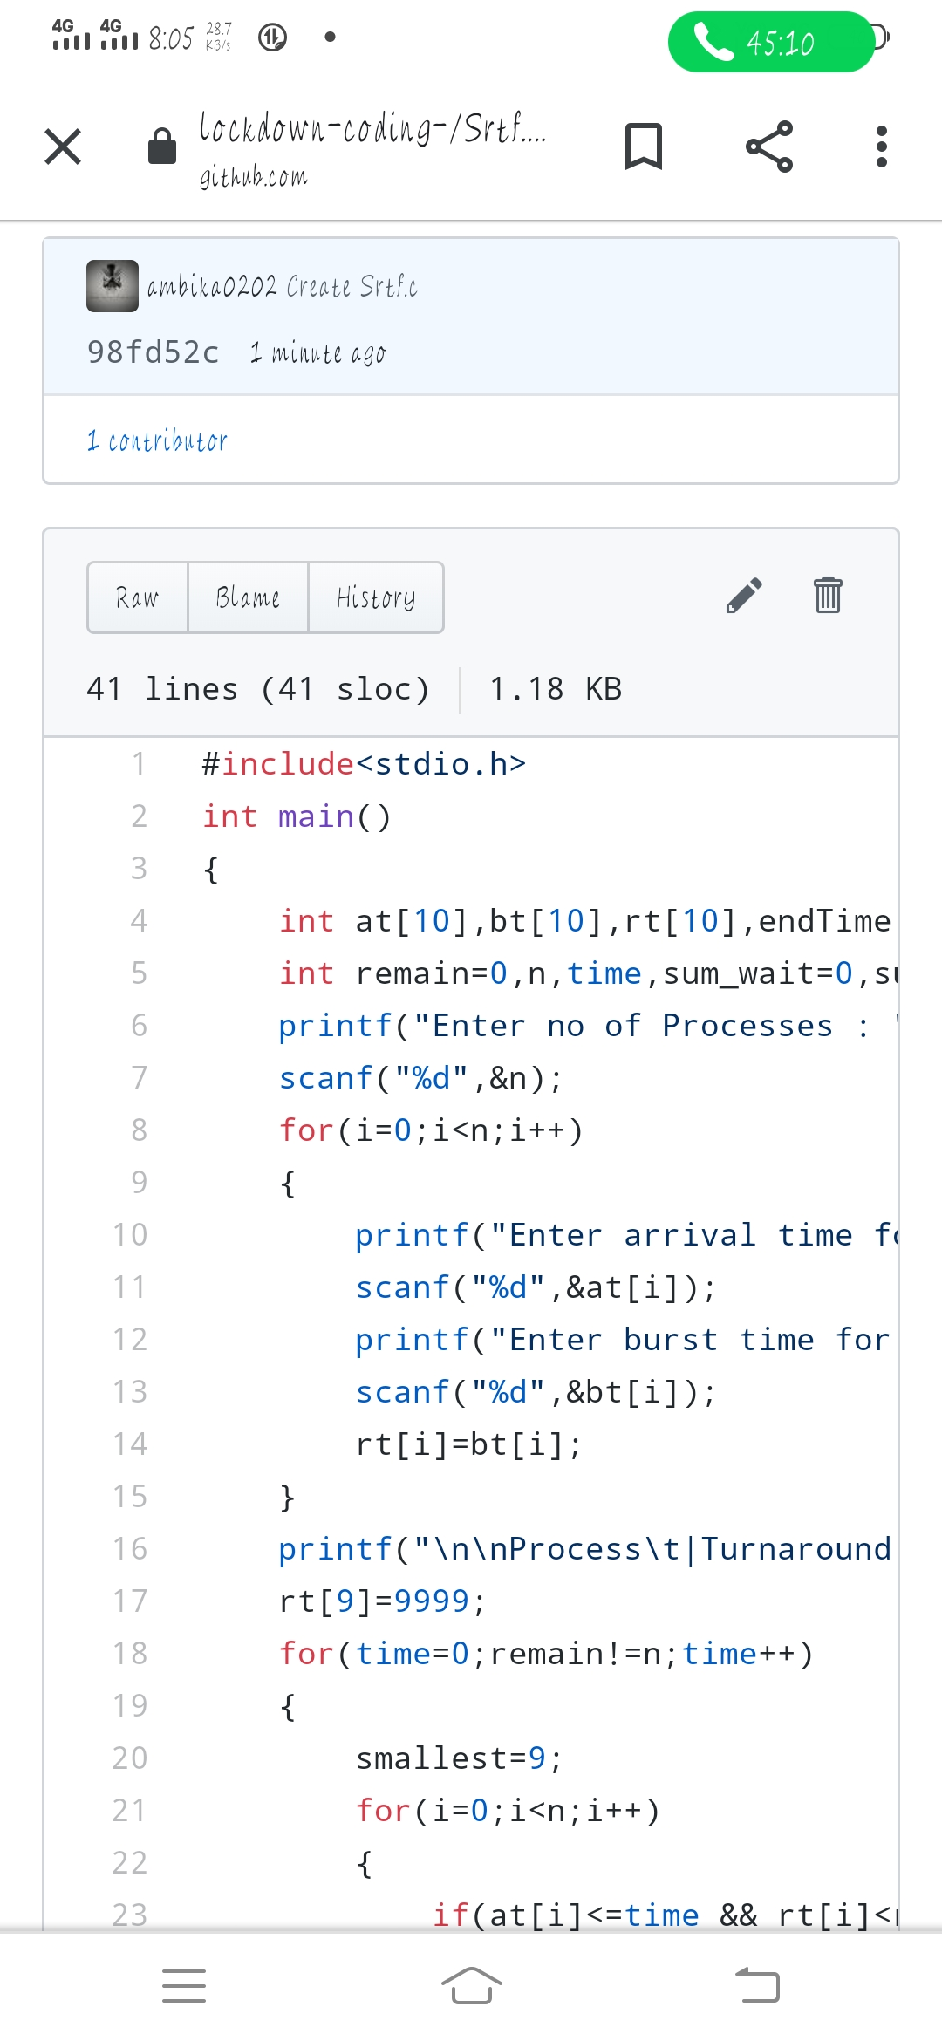

**Problem statement 2 :** Write a C program to construct a singly linked list by removing duplicate elements in the sorted linked list

Description: Take a sorted list and traverse the list. Compare the current node element with next adjacent node. If it is same then delete second element, if not retain. Finally print the resulting list.

Sample output:

Given list {1,2,2,3,3,3,4}

Resulting list{1,2,3,4}

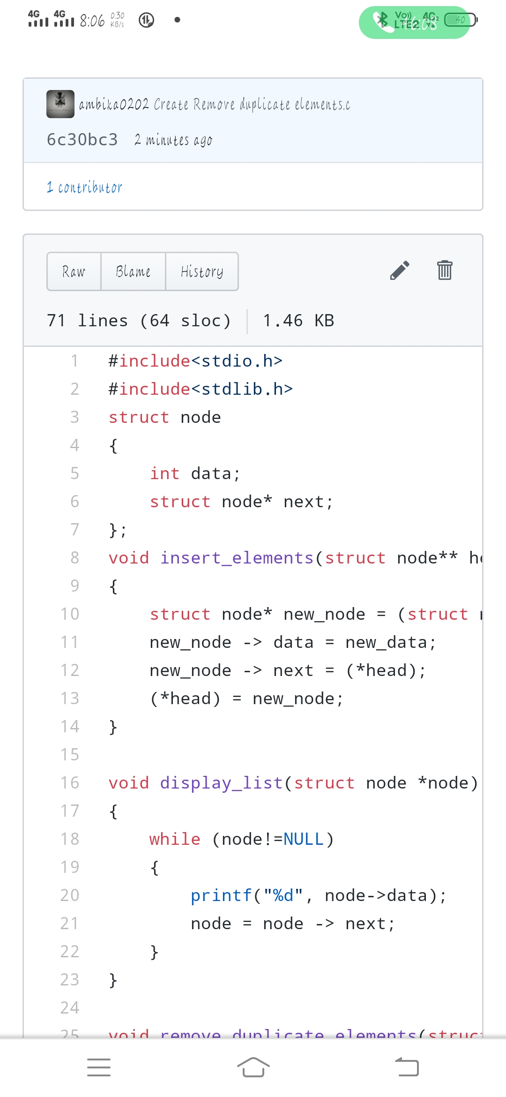

**Problem statement 3 :** Write a c program to create sll with n elements and reverse the elements using c.

